|  |  |
| --- | --- |
|  |  |

**Faculty of Technology and Engineering**

**Chandubhai S Patel Institute of Technology**

**Department of Computer Science & Engineering**

**PRACTICAL – 2**

Roll no.: Date:    /    /

|  |  |  |  |  |  |
| --- | --- | --- | --- | --- | --- |
| Academic Year | : | 2024-25 | Semester | : | 4 |
| Course code | : | CSE207 | Course name | : | Design and Analysis of Algorithms |

**AIM:**

|  |  |
| --- | --- |
| **2.1 Implement and analyze the best case, average case and worst case of the algorithms for problems given below.** | |
| 2.1(a) | Given a **sorted array** of integers, find the **first occurrence** of a target element **x**. If the target element is not found, return **-1**.  Explore alternatives of searching such elements and analyze. |
| 2.1(b) | Given an array of integers, use **Insertion Sort** algorithm to sort the array in ascending order. |
|  |  |

**2.1.1 (a) Data table:  linear search algorithm**

|  |  |  |  |
| --- | --- | --- | --- |
| **Input** | **Best Case** | **Average Case** | **Worst Case** |
| **5** | **1** | **2** | **5** |
| **10** | **1** | **5** | **10** |
| **15** | **1** | **7** | **15** |
| **20** | **1** | **10** | **20** |
| **25** | **1** | **12** | **25** |

**2.1.1 (b) Line Chart:  linear search algorithm**

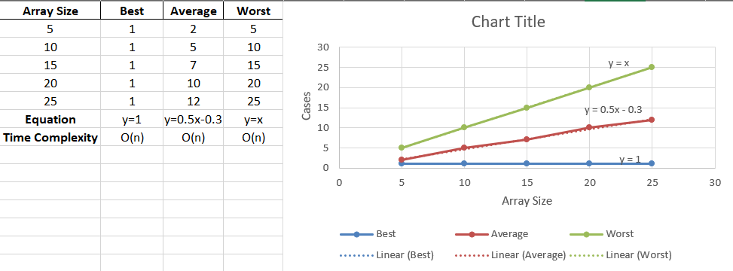

**2.1.2 (a) Data table:  binary search algorithm**

|  |  |  |  |
| --- | --- | --- | --- |
| **Input** | **Best Case** | **Average Case** | **Worst Case** |
| **5** | **1** | **2** | **3** |
| **10** | **1** | **3** | **4** |
| **15** | **1** | **3** | **4** |
| **20** | **1** | **4** | **5** |
| **25** | **1** | **4** | **5** |

**2.1.2 (b) Line Chart:  binary search algorithm**

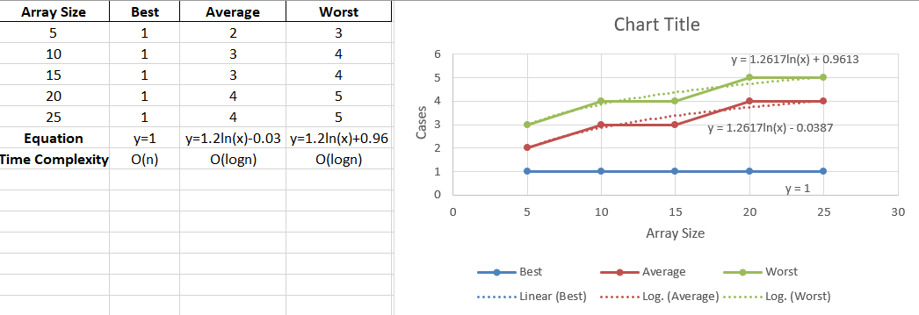

**2.2.1 (a) Data table:  insertion sort algorithm**

|  |  |  |  |
| --- | --- | --- | --- |
| **Input** | **Best Case** | **Average Case** | **Worst Case** |
| **5** | **4** | **10** | **15** |
| **10** | **9** | **32** | **55** |
| **15** | **14** | **67** | **120** |
| **20** | **19** | **115** | **210** |
| **25** | **24** | **175** | **325** |

**2.2.2 (b) Line Chart:  insertion sort algorithm**

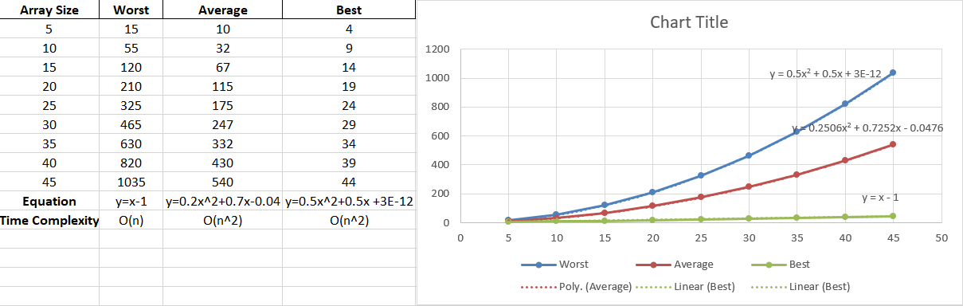

**Conclusion:**

|  |  |
| --- | --- |
|  |  |

**Faculty of Technology and Engineering**

**Chandubhai S Patel Institute of Technology**

**Department of Computer Science & Engineering**

**Performa for PRACTICAL – 2**

Roll no.: Date:    /    /

|  |  |  |  |  |  |
| --- | --- | --- | --- | --- | --- |
| Academic Year | : | 2024-25 | Semester | : | 4 |
| Course code | : | CSE207 | Course name | : | Design and Analysis of Algorithms |

**AIM:**

|  |  |
| --- | --- |
| **2.1 Implement and analyze the best case, average case and worst case of the algorithms for problems given below.** | |
| 2.1(a) | Given a **sorted array** of integers, find the **first occurrence** of a target element **x**. If the target element is not found, return **-1**.  Explore alternatives of searching such elements and analyze. |
| 2.1(b) | Given an array of integers, use **Insertion Sort** algorithm to sort the array in ascending order. |

**Answer the following Questions:**

1. How does insertion sort outperform selection sort when the elements are already sorted? Justify your answer.
2. Can insertion sort be optimized using binary search in terms of number of comparison, number of shifts and overall time complexity?

**Grade / Marks Sign of Lab Teacher with Date**